**NVIDIA ® Jetson Nano developer Kit**

* The biggest feature of Nano is that it includes a 128-core Maxwell architecture GPU.
* Jetson Nano is a small, powerful computer for embedded applications
* AI IoT that delivers the power of modern AI in 99 $.
* Get started fast with the comprehensive [JetPack SDK](https://developer.nvidia.com/embedded/jetpack) with accelerated libraries for deep learning, computer vision, graphics, multimedia, and more.
* Jetson Nano has the performance and capabilities you need to run modern AI workloads, giving you a fast and easy way to add advanced AI to your next product.
* NVIDIA® Jetson Nano™ Developer Kit is a small, powerful computer that lets you run multiple neural networks in parallel for applications like image classification, object detection, segmentation, and speech processing. All in an easy-to-use platform that runs in as little as 5 watts.
* It’s simpler than ever to get started! Just insert a microSD card with the system image, boot the developer kit, and begin using the same [NVIDIA JetPack SDK](https://developer.nvidia.com/embedded/jetpack) used across the entire [NVIDIA Jetson™ family of products](https://developer.nvidia.com/embedded/develop/hardware).
* JetPack is compatible with NVIDIA’s world-leading AI platform for training and deploying AI software, reducing complexity and effort for developers.

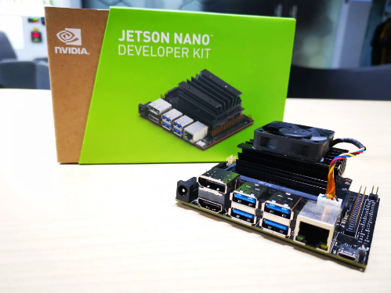

[**JetPack SDK**](https://developer.nvidia.com/embedded/jetpack)

NVIDIA JetPack SDK is the most comprehensive solution for building AI applications. Flash your Jetson developer kit with the latest OS image, install developer tools for both host computer and developer kit, and install the libraries and APIs, samples, and documentation needed to jumpstart your development environment.

**Specifications:**

|  |  |
| --- | --- |
| **GPU** | NVIDIA Maxwell architecture with 128 NVIDIA CUDA® cores |
| **CPU** | Quad-core ARM Cortex-A57 MPCore processor |
| **Memory** | 4 GB 64-bit LPDDR4, 1600MHz 25.6 GB/s |
| **Storage** | 16 GB eMMC 5.1 |
| **Video Encode** | 250MP/sec 1x 4K @ 30 (HEVC) 2x 1080p @ 60 (HEVC) 4x 1080p @ 30 (HEVC) 4x 720p @ 60 (HEVC) 9x 720p @ 30 (HEVC) |
| **Video Decode** | 500MP/sec 1x 4K @ 60 (HEVC) 2x 4K @ 30 (HEVC) 4x 1080p @ 60 (HEVC) 8x 1080p @ 30 (HEVC) 9x 720p @ 60 (HEVC) |
| **Camera** | 12 lanes (3x4 or 4x2) MIPI CSI-2 D-PHY 1.1 (1.5 Gb/s per pair) |
| **Connectivity** | Gigabit Ethernet, M.2 Key E |
| **Display** | HDMI 2.0 and eDP 1.4 |
| **USB** | 4x USB 3.0, USB 2.0 Micro-B |
| **Others** | GPIO, I2C, I2S, SPI, UART |
| **Mechanical** | 69.6 mm x 45 mm 260-pin edge connector |